[TNC connection for exchange - Ubuntu]

1. Setting Up blockchain node
2. When you first run ./tncd from the downloaded file, the config.ini file and log_config.ini file are created inside the node_data_dir folder. After running for the first time, Press Ctrl+C to force shutdown and then setup the config.ini and log_config.ini 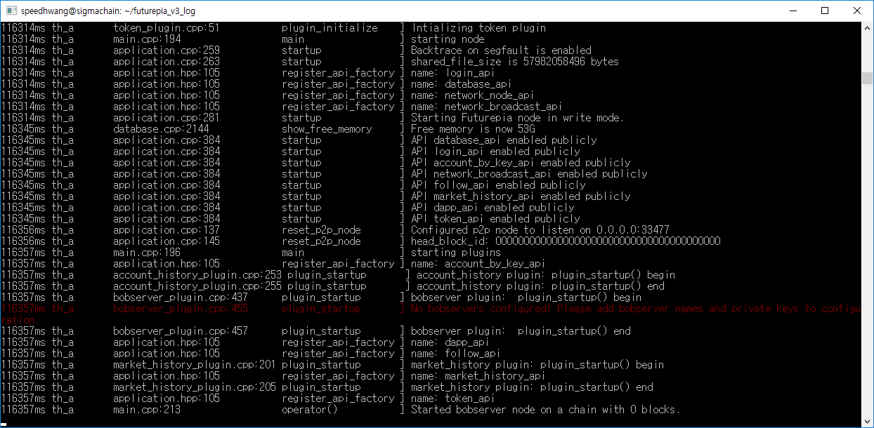

Pressing Ctrl + C will force shutdown the program.

1. Set the config.ini file through vi node_data_dir / config.ini.

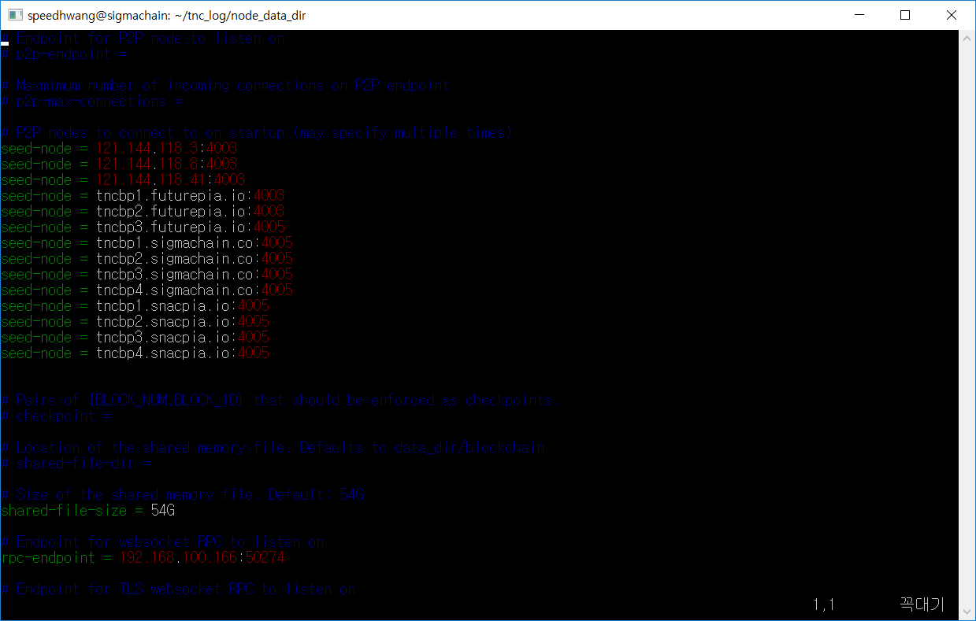

p2p-endpoint : Settings for the IP and port number of this node to which other block-chain nodes will connect.

seed-node : Other blockchain nodes to which this node will connect

|  |
| --- |
| seed-node = 13.125.211.3:4003  seed-node = 13.125.199.76:4003  seed-node = 3.35.166.98:4003  seed-node = 54.180.128.144:4003  seed-node = 3.36.105.187:4003  seed-node = 3.36.73.243:4003  seed-node = 3.36.77.153:4003  seed-node = 3.36.100.214:4003 |

rpc-endpoint : This is the IP, port to communicate with the NodeJS API. It is secure to have blockchain nodes and NodeJS APIs on one server by setting them to 127.0.0.1

1. Run the vi node_data_dir / log_config.ini to set the log.

There are settings to either view the logs during runtime of the program or save the logs in a file. Only one of the two methods should be selected.

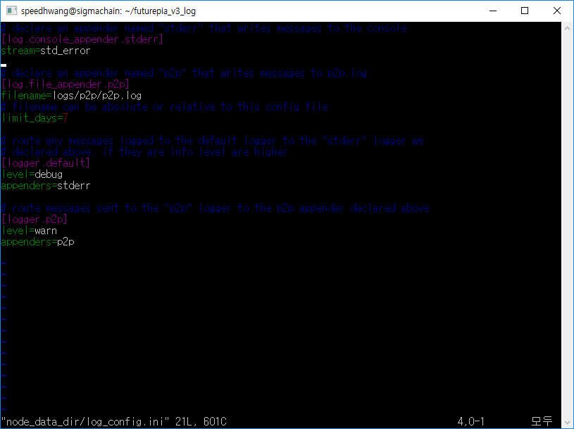

<Settings that the logs are seen at console during the runtime>

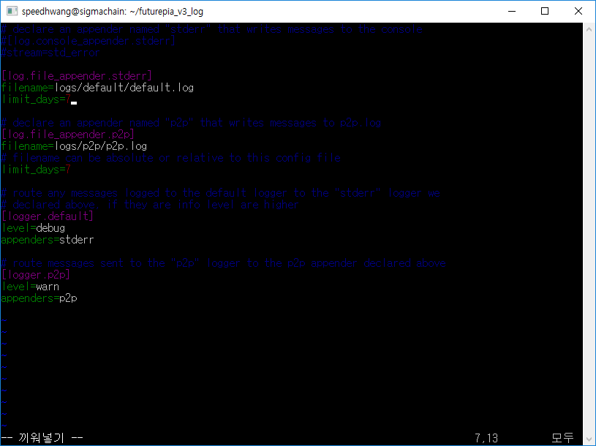

<Settings to save the logs in a file >

limit_days : Number of days to keep log files (delete logs older than 7 days)

level : Level of the output log ( select one from warn, debug and info)

1. Run ./tncd to connect to TNC MainNet and receive block. ( for background Run ./tncd &)

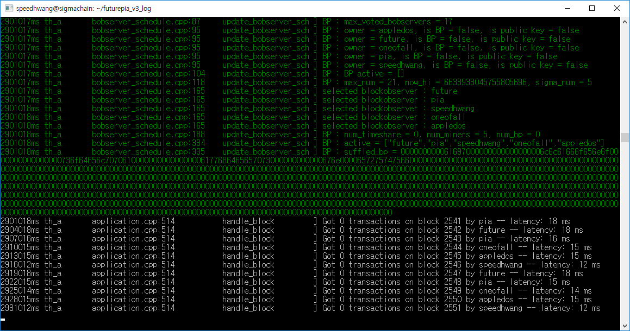

1. If you choose save log files.. you can find /node_data_dir/logs/default/default.log
2. Run cli_wallet

> ./cli_wallet -s ws://[your blockchain ip]:[rpc_port] -r [you’r cli_wallet ip]:[rpc_port] -d

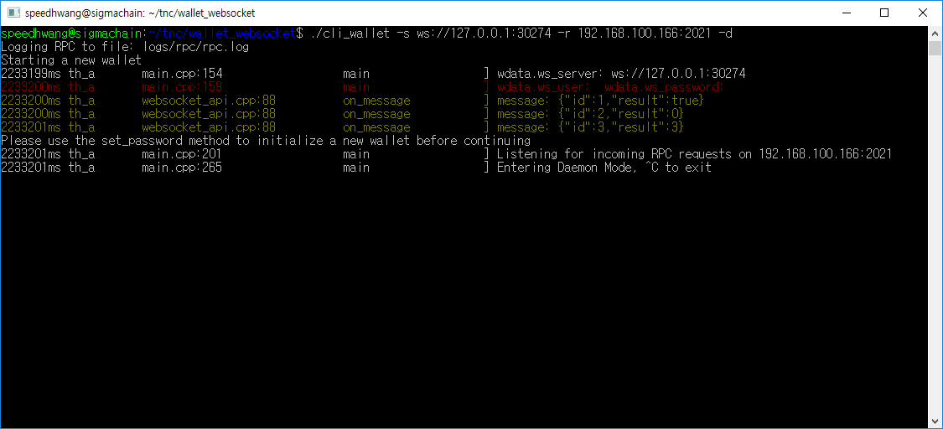

1. Set password / unlock for cli_wallet
2. The first time you run it, you have to set a password.

|  |  |
| --- | --- |
| Json RPC | {"jsonrpc": "2.0", "method": "set_password", "params": [“you’r password”], "id":1 } |
| result | {"id":1,"result":null} |

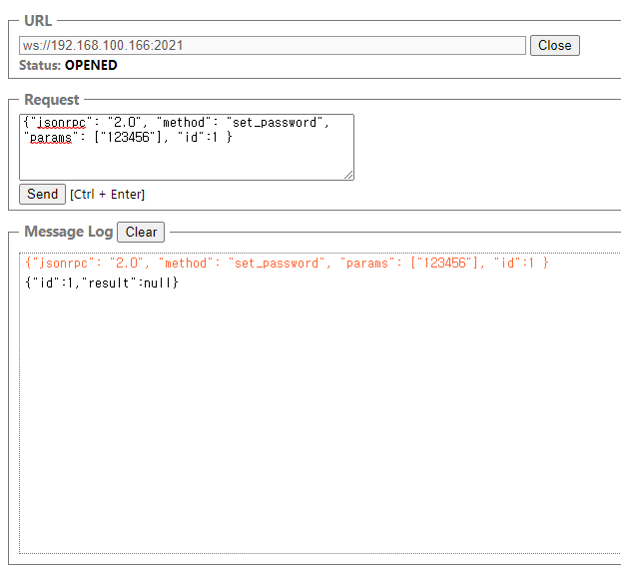

1. Unlock the cli_wallet

|  |  |
| --- | --- |
| Json RPC | {"jsonrpc": "2.0", "method": "unlock", "params": [“you’r password”], "id":1 } |
| result | {"id":1,"result":null} |

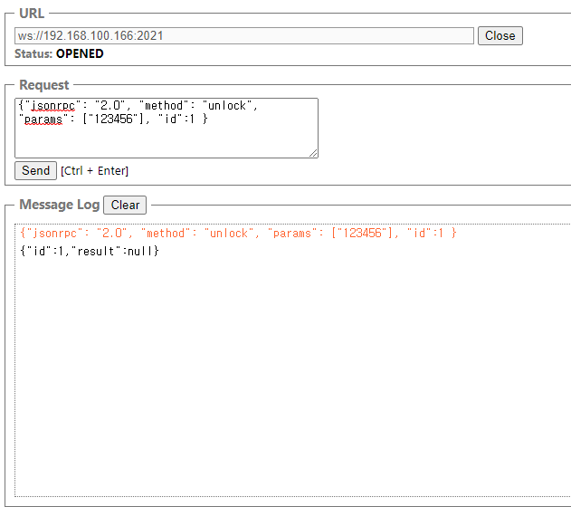

1. lock the cli_wallet

|  |  |
| --- | --- |
| Json RPC | {"jsonrpc": "2.0", "method": "lock", "params": [], "id":1 } |
| result | {"id":1,"result":null} |

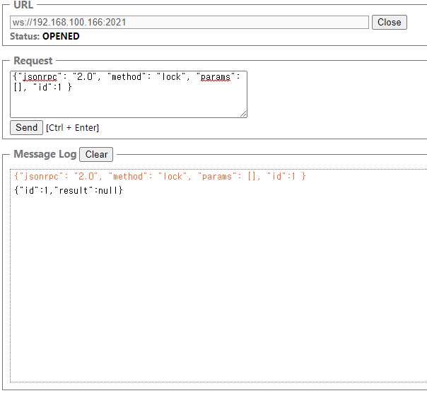

1. cli_wallet Reference

# info

|  |  |
| --- | --- |
| Json RPC | {"jsonrpc": "2.0", "method": "info", "params": [], "id":1 } |
| result | {"id":1,"result":{  "id":0,  "head_block_number":21757,  "head_block_id":"000054fd8be6420814e0d9ab9b91a3676de91b50",  "time":"2020-10-14T00:45:06",  "current_bobserver":"chainmaker",  "current_supply":"1000000000000.000000 TNC",  "maximum_block_size":1333788672,  "current_aslot":10506621,  "recent_slots_filled":"340282366920938463463374607431768211455",  "participation_count":128,  "last_irreversible_block_num":21736,  "current_bproducer_count":0,  "next_update_bproducer_owner_time":"1970-01-01T00:00:00",  "last_dapp_voting_aggregation_time":"2020-10-14T00:15:09",  "current_reserve_ratio":200000000,  "average_block_size":122,  "bobserver_majority_version":"0.0.0",  "hardfork_version":"0.1.0",  "head_block_num":21757,  "head_block_age":"0 second old",  "participation":"100.00000000000000000"  }} |

# get_block

|  |  |
| --- | --- |
| Json RPC | {"jsonrpc": "2.0", "method": "get_block", "params": ["10"], "id":1 } |
| result | {"id":1,"result":{  "previous":"00000009c7d9390768397ff12b9cc1294d1c973f",  "timestamp":"2020-09-25T06:14:42",  "bobserver":"chainmaker",  "transaction_merkle_root":"0000000000000000000000000000000000000000",  "extensions":[],  "bobserver_signature":"206bc300b1cadb6…",  "transactions":[],  "block_id":"0000000af48e5aea93a15b944187c0c5dbfb1e35",  "signing_key":"TNC8AC92qZFLfzvZ5hQtL4L7ZdmbEMkj3otccobDGcSrRQjSY4fhG",  "transaction_ids":[]  }} |

# get_account

|  |  |
| --- | --- |
| Json RPC | {"jsonrpc": "2.0", "method": "get_account", "params": ["chainmaker"], "id":1 } |
| result | {"id":1,"result":{  "id":3,  "name":"chainmaker",  "owner":{"weight_threshold":1,"account_auths":[],"key_...,  "active":{"weight_threshold":1,"account_auths":[],"key_...,  "posting":{"weight_threshold":1,"account_auths":[],"key_...,  "memo_key":"TNC8AC92qZFLfzvZ…",  …  "balance":"0.000000 TNC",  "savings_balance":"0.000000 TNC",  "post_count":0,  "last_post":"1970-01-01T00:00:00",  "last_root_post":"1970-01-01T00:00:00"  }} |

# Import_key

|  |  |
| --- | --- |
| Json RPC | {"jsonrpc": "2.0", "method": "import_key", "params": ["5JC5q5EbSYSET7SStvf7u7sm9AAyLdSSnVojTVqmMtNZ3mZmAVo"], "id":1 } |
| result | {"id":1,"result":true} |

5JC5q5EbSYSET7SStvf7u7sm9AAyLdSSnVojTVqmMtNZ3mZmAVo is mainnet exchange’s private key. Use for mainnet exchange’s create_account

# create_account

|  |  |
| --- | --- |
| Json RPC | {"jsonrpc": "2.0", "method": "create_account", "params": ["exchange", "your account", "", true], "id":1 } |
| result | {"id":1,"result":{  "ref_block_num":22370,  "ref_block_prefix":1598497977,  "expiration":"2020-10-14T01:16:15",  "operations":[[  "account_create",{  "creator":"exchange",  "new_account_name":"testte2",  "owner":{  "weight_threshold":1,  "account_auths":[],  "key_auths":[["TNC594hA3MSc5rujaYksAJ3ZLCWD9JiFE9YYWEfnknb2S8SiMo4UP",1]]},  "active":{"weight_threshold":1,"account_auths":[],"key_auths":[["TNC8ACjN…p66Ev6XLwkEa1",1]]},  "posting":{"weight_threshold":1,"account_auths":[],"key_auths":[["TNC6CDb…eNEZhKZrU6vf2v",1]]},  "memo_key":"TNC6jRFcGnM76K1cm8XFKsPZztLDmbZiNBd9k4EZopzbx3QTZDnMw",  "json_metadata":""  }]],  "extensions":[],  "signatures":["1f60a24e125b9d8901199ac88077…71de3a450eec96fc1e258b7e0ae65"],  "transaction_id":"07e34d6e0cdbb27abb1def5563c1d45ed2404116",  "block_num":22371,  "transaction_num":0}} |

# get_private_key_from_password

|  |  |
| --- | --- |
| Json RPC | {"jsonrpc": "2.0", "method": "get_private_key_from_password", "params": ["your id", "active", "password"], "id":1 } |
| result | {"id":1,"result":  [  "TNC8fYbGNiAsbNsgMjfxFu7F13RxBqjRTnxFSjmgcUZoXEpkJJY6j",  "5Jrq1hn8Pi9YHYUy9XbvLQ8g6EweL2houANDUz379oynNdri2VY"  ]} |

Used to generate a key for the wallet's key.

# suggest_brain_key

|  |  |
| --- | --- |
| Json RPC | {"jsonrpc": "2.0", "method": "suggest_brain_key", "params": [], "id":1 } |
| result | {"id":1,"result":{  "brain_priv_key":"POSCA GIPSER LANATED GANDUM CHOCHO SARK GRUFTED AFGHANI SILAGE PITCHI DISTAIN YARL ROYET MYRICIN SUNN ROWEN",  "wif_priv_key":"5KdhpLtfEiTAcXZf54sXFCi9L7D3rr4qWrLqKjGUfsD676q7a4E",  "pub_key":"TNC6PYKrKN1RoiBEvuurJtgMGuD1Bx3AzcnZaMjMURhjYrmKcvQPw"  }} |

Used to generate a key for the wallet's key.

# update_account

|  |  |
| --- | --- |
| Json RPC | {"jsonrpc": "2.0", "method": "update_account", "params":  ["you’r id","","owner key for change","active key for change","posting key for change","memo key for change", true], "id":1 } |
| result | {"id":1,"result":{  "ref_block_num":23005,  "ref_block_prefix":357186352,  "expiration":"2020-10-14T01:50:33",  "operations":[[  "account_update",{  "account":"testte2",  "owner":{"weight_threshold":1,"account_auths":[],"key_auths":[["TNC8Hi1By…bKMMujap5GwYNrwfz",1]]},  "active":{"weight_threshold":1,"account_auths":[],"key_auths":[["TNC8Ruybnr…6CkAKE19nTNpX5vrNp2wnQ4bX",1]]},  "posting":{"weight_threshold":1,"account_auths":[],"key_auths":[["TNC8c9upw9vHe…2T4TB7HSpCE5W",1]]},  "memo_key":"TNC77WKXStronBCm39bVjGZy3zvS2NNKN5Hryzk5ABWhsmDzJfTcN",  "json_metadata":""  }]],  "extensions":[],  "signatures":["2062605085e4158b4c12ef431f9…6c9c138ef6c20677e866f4b4cb7459"],  "transaction_id":"ce684e7f9158785af25470fbc957529ccb511f97","block_num":23006,"transaction_num":0}} |

Update wallet’s key. Use public key created suggest_brain_key or get_private_key_from_password

After update wallet’s key. for transfer, Must impory_key private key to changed key.

owner key : used to update all key

active key : used to transfer

posting key : not use

memo key : used to transfer memo crypto (memo prefix ‘#’)

# get_private_key

|  |  |
| --- | --- |
| Json RPC | {"jsonrpc": "2.0", "method": "get_private_key", "params": ["TNC8Hi1BytT8UHfAU8SYUkhNUepdmSFgjiCYbKMMujap5GwYNrwfz"], "id":1 } |
| result | {"id":1,"result":"5J2XEo3XxU3HvMQDgLvpyw1EvbeHh7Lvey49qfzACnYgsj91B3C"} |

# transfer

|  |  |
| --- | --- |
| Json RPC | {"jsonrpc": "2.0", "method": "transfer", "params": ["from wallet", "to wallet", "amount(ex.1.000000 TNC)", "", true], "id":1 } |
| result | {"id":1,"result":{  "ref_block_num":23328,  "ref_block_prefix":1997813487,  "expiration":"2020-10-14T02:06:42",  "operations":[[  "transfer",{  "from":"testte2",  "to":"testte",  "amount":"1.000000 TNC",  "memo":""  }]],  "extensions":[],  "signatures":["2023d2e2794cdb346ee9e78d0f0da0e7…184ed683d8ac09f67b27bc1087e8edbacdd"],  "transaction_id":"f44cb5f9d484390f7926926315402ebfe0d0eeae",  "block_num":23329,  "transaction_num":0} |

# get_transaction

|  |  |
| --- | --- |
| Json RPC | {"jsonrpc": "2.0", "method": "get_transaction", "params": ["ca4cb31ff4d042fefadffdbfe3e01261b3b939c7"], "id":1 } |
| result | {"id":1,"result":{  "ref_block_num":21367,  "ref_block_prefix":1319696067,  "expiration":"2020-10-14T00:22:51",  "operations":[[  "transfer",{  "from":"tncadmin",  "to":"testte","amount":"1000.000000 TNC",  "memo":""}]],  "extensions":[],  "signatures":["1f3e3cd061b40781e999c5741973a31b84af403e5a5…a7589469545779a4dd5b68ff6da8967df"],  "transaction_id":"ca4cb31ff4d042fefadffdbfe3e01261b3b939c7",  "block_num":21368,  "transaction_num":0}} |

# get_account_history

start index : -1 is lastest number. This case, Next start index set 16455

|  |  |
| --- | --- |
| Json RPC | {"jsonrpc": "2.0", "method": "get_account_history", "params": ["account name", start index, number], "id":1 } |
| result | {"id":1,"result":[  [  16456,  {  "trx_id":"cf8af0aa0df8485d352df04ca053724cecd4646f",  "block":53422,  "trx_in_block":0,  "op_in_trx":489,  "virtual_op":0,  "timestamp":"2020-10-27T07:09:18",  "op":[  "transfer",{"from":"tncadmin","to":"ALD7VKAMByjT…FtAMF3PFdAs9sZRa8ntPp","amount":"96000.000000 TNC","memo":"swap"}  ]  }  ],  [  16457,  {  "trx_id":"cf8af0aa0df8485d352df04ca053724cecd4646f",  "block":53422,  "trx_in_block":0,  "op_in_trx":490,  "virtual_op":0,  "timestamp":"2020-10-27T07:09:18",  "op":[  "transfer",{"from":"tncadmin","to":"ALD8MjhP6Z…WWYv7Kmy5gk2HURy6LoweJ","amount":"96000.000000 TNC","memo":"swap"}  ]  }  ],  [  16458,  {  "trx_id":"cf8af0aa0df8485d352df04ca053724cecd4646f",  "block":53422,  "trx_in_block":0,  "op_in_trx":491,  "virtual_op":0,  "timestamp":"2020-10-27T07:09:18",  "op":[  "transfer",{"from":"tncadmin","to":"ALD75VaHhNcqUjSSY…Ugc4JZeayw4hq","amount":"96000.000000 TNC","memo":"swap"}  ]  }  ],  [  16459,  {  "trx_id":"cf8af0aa0df8485d352df04ca053724cecd4646f",  "block":53422,  "trx_in_block":0,  "op_in_trx":492,  "virtual_op":0,  "timestamp":"2020-10-27T07:09:18",  "op":[  "transfer",{"from":"tncadmin","to":"ALD6LNCueNw…VANKQKNjXr8BZt4WB9","amount":"96000.000000 TNC","memo":"swap"}  ]  }  ],  [  … |

# set_transaction_expiration

set transaction expiration seconds. Max value is 3599. Default value is 30

|  |  |
| --- | --- |
| Json RPC | {"jsonrpc": "2.0", "method": "set_transaction_expiration", "params": [3599], "id":1 } |
| result | {"id":1,"result":null} |

1. offline signature using cli_wallet

offline signature must import transfer account’s active private key.

# Run offline wallet

> ./cli_wallet -s local -r [you’r cli_wallet ip]:[rpc_port] -d

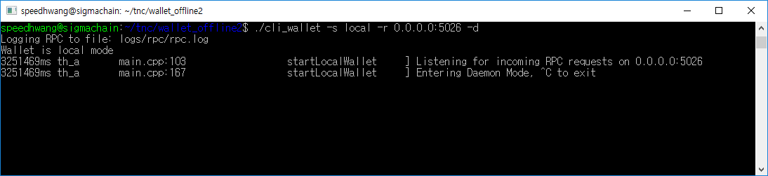

If you are first run. Need set_password, unlock, import_key. ( see the chapter 3, chapter 4 )

In this sample, 5025 port is an online wallet and 5026 port is an offline wallet.

1. create_account

Create four keys of the account to be generated in the offline wallet using sugest_brain_key. (import_key must also be)

Create account using the create_account_key in the online wallet. (imported exchange key. And wallet unlocked)

|  |  |
| --- | --- |
| Json RPC | {"jsonrpc": "2.0", "method": "create_account_with_keys", "params": ["exchange", "you’r account name", "", "public_key1", "public_key2", "public_key3", "public_key4", true], "id":1 } |
| result | {"id":1,"result":{  "ref_block_num":46506,  "ref_block_prefix":2781310262,  "expiration":"2020-10-27T00:32:15",  "operations":[[  "account_create",{  "creator":"exchange",  "new_account_name":"test10",  "owner":{"weight_threshold":1,"account_auths":[],"key_auths":[["TNC6BjAZk8wohDA8bDUzYsNXVt7z9PmutZmCrtXj3yZ8q5PHFE8Mk",1]]},  "active":{"weight_threshold":1,"account_auths":[],"key_auths":[["TNC5chwAoerjgDKmJ4oJi1qEL8J2MFmxPAdczy3CKEWmPSDQQkX8r",1]]},  "posting":{"weight_threshold":1,"account_auths":[],"key_auths":[["TNC6BGdLWHp3LmWXohJrdLNyfnUR4DMRcsVtWwhXM2krUEzTzXz3D",1]]},  "memo_key":"TNC6PyMxVtd6w5iKbSXddBX7B4QJEoM8iB3i2Q13xgUJDNaY8pcu7","json_metadata":""}  ]],  "extensions":[],"signatures":["1f3aa92b28d87d10b4be4fdd…21c6cd8c3ae"],  "transaction_id":"7e622ac93d36111859d97782d075d1a9c106a2a8",  "block_num":46507,  "transaction_num":0}} |

1. send transfer_offline to online wallet.

|  |  |
| --- | --- |
| Json RPC | {"jsonrpc": "2.0", "method": "transfer_offline", "params": ["tncadmin","speedhwang","1.100000 TNC" "memo"], "id":1 } |
| result | {"id":1,"result":{  "ref_block_num":42113,  "ref_block_prefix":3428897739,  "expiration":"2020-10-26T01:05:15",  "operations":[[  "transfer",{  "from":"tncadmin",  "to":"speedhwang",  "amount":"1.100000 TNC",  "memo":"memo"  }  ]],  "extensions":[],  "signatures":[],  "pkeys":["TNC5FHVSGXZCSxA3vyPmjGc4hT3FzcSqZKKeb3qwkmVpPQhTeTvyX"]} } |

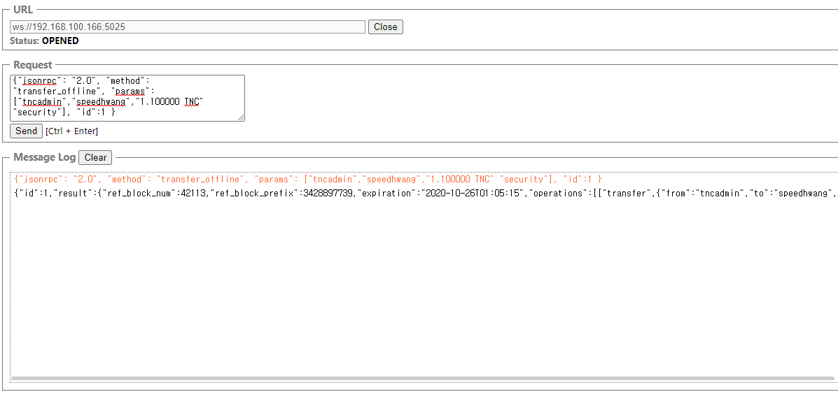

1. send sign_offline_transaction to offline wallet. (input the transfer_offline result in params)

|  |  |
| --- | --- |
| Json RPC | {"jsonrpc": "2.0", "method": "sign_offline_transaction",  "params": [  {"ref_block_num":40139,"ref_block_prefix":1440310417,"expiration":"2020-10-23T02:56:24","operations":[["transfer",{"from":"tncadmin","to":"speedhwang","amount":"1.100000 TNC","memo":"memo"}]],"extensions":[],"signatures":[],"pkeys":["TNC5FHVSGXZCSxA3vyPmjGc4hT3FzcSqZKKeb3qwkmVpPQhTeTvyX"]}  ], "id":1 } |
| result | {"id":1,"result":{  "ref_block_num":40139,  "ref_block_prefix":1440310417,  "expiration":"2020-10-23T02:56:24",  "operations":[[  "transfer",{  "from":"tncadmin",  "to":"speedhwang",  "amount":"1.100000 TNC",  "memo":"memo"  }  ]],  "extensions":[],  "signatures":["20188c11a573a4…1bd5e5a71c43f"]} } |

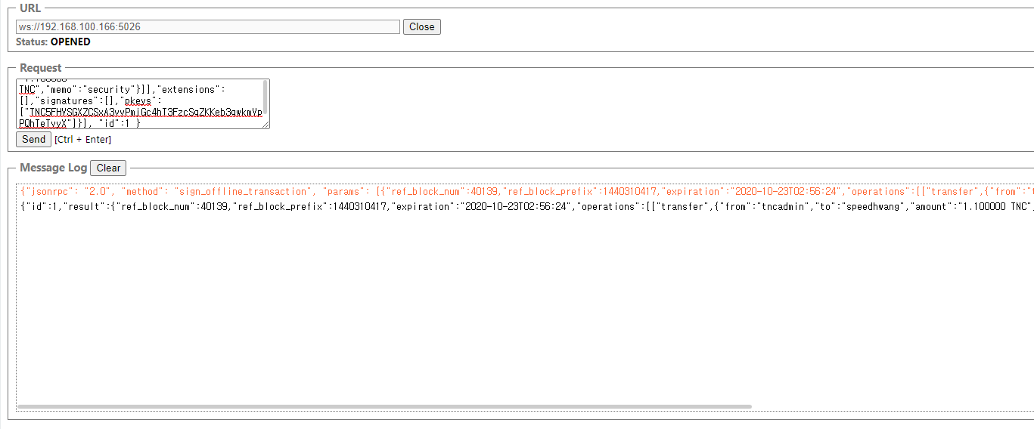

1. send push_transaction to online wallet. (input the sign_offline_transaction result in params)

|  |  |
| --- | --- |
| Json RPC | {"jsonrpc": "2.0", "method": "push_transaction",  "params": [  {"ref_block_num":40139,"ref_block_prefix":1440310417,"expiration":"2020-10-23T02:56:24","operations":[["transfer",{"from":"tncadmin","to":"speedhwang","amount":"1.100000 TNC","memo":"security"}]],"extensions":[],"signatures":["20188c11a573a49ec1f7b6…d3c28cfaa6aa6be2b9fe66d91bd5e5a71c43f"]}, true  ], "id":1 } |
| result | {"id":1,"result":{  "ref_block_num":42361,  "ref_block_prefix":684249199,  "expiration":"2020-10-26T01:17:39",  "operations":[[  "transfer",{  "from":"tncadmin",  "to":"speedhwang",  "amount":"1.100000 TNC",  "memo":"memo"  }  ]],  "extensions":[],  "signatures":["1f6c85f887db2ebc9af4604c1d846c548edd76808cd9174….91485a362847f3938916b9b85f92b"],  "transaction_id":"ab0382fbeb07fdd0287b951572eb3f9b8216b88a",  "block_num":42374,  "transaction_num":0}} |

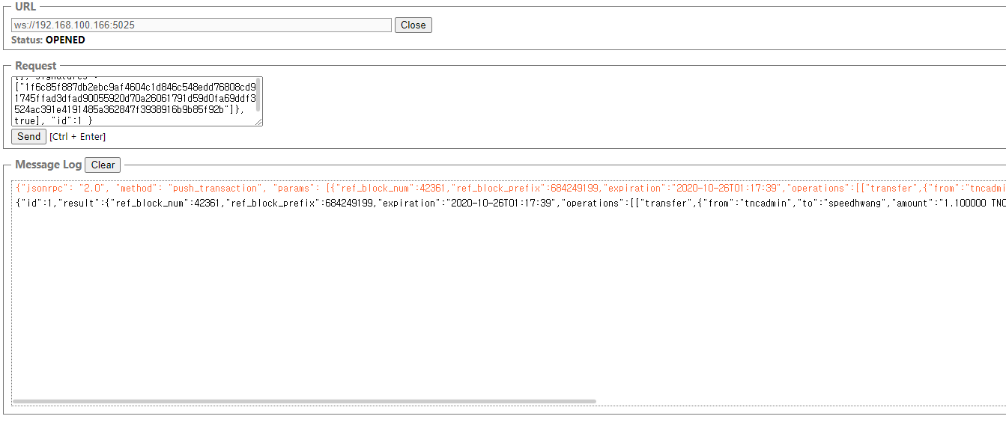

1. NodeJS Install

> sudo apt-get install nodejs nodejs-legacy npm -y

> sudo apt-get install build-essential libssl-dev -y

> sudo npm cache clean -f

> sudo npm install -g n

> sudo n 6.14.2

> sudo ln -sf /usr/local/n/versions/node/6.14.2/bin/node /usr/bin/node

> sudo npm install forever -g

> forever start --uid tnc_node -a src/app.js

1. NodeJS API Setting

To connect to the blockchain node, set up using the following information.

Setting File : src/config/config.js

|  |
| --- |
| module.exports = {  mode : 'development',  version : '0',  port : 3030,  api_url : "ws://127.0.0.1:10274",  address_prefix : "TNC",  fee_string : "TNC",  fee_string_rpad : 6,  creator : "exchange",  creator_wif : "5JC5q5EbSYSET7SStvf7u7sm9AAyLdSSnVojTVqmMtNZ3mZmAVo",  chain_id: "0000000000000000000000000000000000000000000000000000000000000000",  }; |

port : The port number that the NodeJS API will open.

api_url : Information about RPC connection of the blockchain node (rpc-endpoint of the blockchain node)

creator : Default name for the account creator given at the time of creating account

creator_wif : active private key of creator

1. NodeJS API Reference

You can import blockchain information and send coins by connecting to the nodeJS API that you set up.

# getConfig

|  |  |
| --- | --- |
| URL | /api/getConfig |
| Method | POST |
| Explain | View the current settings of the blockchain node. |
| Parameter | N/A |
| Result | {  "status":"success",  "result":{  “SIGMAENGINE_100_PERCENT":10000,  "SIGMAENGINE_1_PERCENT":100,  "SIGMAENGINE_1_TENTH_PERCENT":10,  "SIGMAENGINE_ACCOUNT_RECOVERY_REQUEST_EXPIRATION_PERIOD":"86400000000",  "SIGMAENGINE_ADDRESS_PREFIX":"TNC",  "SIGMAENGINE_BLOCKCHAIN_PRECISION_DIGITS":6,  "SIGMAENGINE_BLOCKCHAIN_HARDFORK_VERSION":"0.1.0",  "SIGMAENGINE_BLOCKCHAIN_VERSION":"0.1.0"  ………………….  }  } |

# getDynamicGlobal

|  |  |
| --- | --- |
| URL | /api/getDynamicGlobal |
| Method | POST |
| Explain | View the current settings of the blockchain node. |
| Parameter | N/A |
| Result | {  "status":"success",  "result":{  "id":0,  "head_block_number":9942,  "head_block_id":"000026d6efbbb58662dfc0d1bf5946def2334dfe",  "time":"2020-09-22T06:35:18",  "current_bobserver":"chainmaker",  "current_supply":"1000000000000.000000 TNC",  "maximum_block_size":1333788672,  "current_aslot":9880025,  "recent_slots_filled":"340282366920938463463374607431768211455",  "participation_count":128,  "last_irreversible_block_num":9921,  .....  }  } |

# getBlock

|  |  |
| --- | --- |
| URL | /api/getBlock |
| Method | POST |
| Explain | Check block information of the blockchain node. |
| Parameter | blockNum : Block number you want to look up |
| Result | {  "status":"success",  "result":{  "previous":"00000009c5e7ac115ccaadaff2630dcc770a51d7",  "timestamp":"2018-11-30T02:47:48",  "bobserver":"oneofall",  "transaction_merkle_root":"0000000000000000000000000000000000000000",  "extensions":[],  "bobserver_signature":,  "transactions":[],  "block_id":"0000000a81bad9a617d33a14749b161c0fb42a70",  "signing_key":"TNC5UsygUhUrtVyKJBkicTnTtdAhRgtfR1i5xasKEHXr1G7SSd1UQ",  "transaction_ids":[]  }  } |

# get_account

|  |  |
| --- | --- |
| URL | /api/getAccounts |
| Method | POST |
| Explain | Check the account information |
| Parameter | usernames (json style string ex) ["test1","test2"] ) |
| Result | {  "status":"success",  "result":[  {  "id":4,  "name":"lighttiger",  "owner":{"weight_threshold":1,  "account_auths":[],  "key_auths":[["TNC81NseJFBqVo2vxC3fHgzExwZxkRdNKZ6aicmfXKDDSWuMbaqes",1]]},  "active":{"weight_threshold":1,  "account_auths":[],  "key_auths":[[" TNC 7zUHBsqGqbQYNPsHwSQAuHahNQKraavzzdXfTccTFQVCyDvYJt",1]]},  "posting":{"weight_threshold":1,  "account_auths":[],  "key_auths":[[" TNC 8VbCohrvvGN2cj77URTHh1V8GUkuqN4daVi8YtACqZaHXopba5",1]]},  "memo_key":" TNC 8MJFUFfcysYUJUkeyz5wRQk1kNBDfAdkQYmt9owWuZAuBmexeB",  ...  }  ]  } |

# transfer

|  |  |
| --- | --- |
| URL | /api/transfer |
| Method | POST |
| Explain | Transfer TNC coin |
| Parameter | from : Sender Account  from_pwd : password and active private key of sender’s account  to : Receiver account  amount : Amount - upto 8 decimal points  memo : memo  memo_key : If you send memo private key by entering # before the memo content, it will be encrypted. In case a password is entered, memo private key is not required. |
| Result | {"status":"success","result":{"id": "b9ed724a84604c794c7b3b02587c83dfd5131345","block_num":143562,"trx_num":0,"expired":false} |

# createAccount

|  |  |
| --- | --- |
| URL | /api/createAccount |
| Method | POST |
| Explain | Wallet creation |
| Parameter | creator : Creator’s account  creator_wif : active private key or password of creator account  username : Creator account username: 3~16 characters long, first character should be English lowercase, while remaining can be lowercase + numbers  password : Creator account’s password |
| Result | {"status":"success","result": { "id": "ebdbc353d6da01cc3d995887cdde4ccace62351f", "block_num":143582, "trx_num":0,"expired":false}} |

# updateAccount

|  |  |
| --- | --- |
| URL | /api/updateAccount |
| Method | POST |
| Explain | Change the wallet’s password |
| Parameter | username : Account’s username  password : New password  old_password : Current password |
| Result | {"status":"success","result":{"id": "6ba89f2421debadb76afd95c48f8974f9d0332bb","block_num":143604,"trx_num":0,"expired":false}} |

# getTransaction

|  |  |
| --- | --- |
| URL | /api/getTransaction |
| Method | POST |
| Explain | Change the wallet’s password |
| Parameter | transaction_id : transaction id |
| Result | {"status":"success","result":{  "ref_block_num":21367,  "ref_block_prefix":1319696067,  "expiration":"2020-10-14T00:22:51",  "operations":[[  "transfer",{  "from":"tncadmin",  "to":"testte",  "amount":"1000.000000 TNC",  "memo":""}]],  "extensions":[],  "signatures":["1f3e3cd061b40781e999c5741973a31b8…45779a4dd5b68ff6da8967df"],  "transaction_id":"ca4cb31ff4d042fefadffdbfe3e01261b3b939c7",  "block_num":21368,  "transaction_num":0}} |

# getAccountHistory

|  |  |
| --- | --- |
| URL | /api/getAccountHistory |
| Method | POST |
| Explain | Get account’s history |
| Parameter | account : account name  from : start index ( -1 is lastest index, this case… next start index set 69 )  limit : number |
| Result | {"status":"success","result":[  [70,  {  "trx_id":"a529b6884fb43515c9a49df8b5fa039bbb7dd6bf",  "block":755648,  "trx_in_block":0,  "op_in_trx":0,  "virtual_op":0,  "timestamp":"2020-10-19T13:33:12",  "op":["account_create",{"creator":"…..  [71,  {  "trx_id":"9e8ac8ce25236e2b1e5fdd16c3784118e4f53c57",  "block":774769,  "trx_in_block":0,  "op_in_trx":0,  "virtual_op":0,  "timestamp":"2020-10-20T05:29:15",  "op":["account_create",{"creator":"tncadmin","…  [72,  {  "trx_id":"bd3327d7d537eec6e4ff9c4e58ef454e7a29cc3b",  "block":776272,  "trx_in_block":0,  "op_in_trx":0,  "virtual_op":0,  "timestamp":"2020-10-20T06:52:36",  "op….. |